**Names Hovhannes Asatryan**

**Lab 1 (25 points)**

**Descriptive statistics and basketball wins:** Here are the numbers of wins for the 30 National Basketball Association teams in the 2012–2013 season.

|  |  |  |  |  |  |  |  |  |  |
| --- | --- | --- | --- | --- | --- | --- | --- | --- | --- |
| 60 | 44 | 39 | 29 | 23 | 57 | 50 | 43 | 37 | 27 |
| 49 | 42 | 37 | 29 | 19 | 56 | 51 | 40 | 33 | 26 |
| 48 | 42 | 31 | 25 | 18 | 53 | 44 | 40 | 29 | 23 |

1. Create a new file on SPSS and upload the file (2 points).
2. Create a frequency table for the number of wins using the data provided (2 points).
3. What is the Mean, Mode, and Median for the number of wins (2 points)?
4. What is the standard deviation and variation (2 points)?
5. How many teams had over 41 wins (2 points)?
6. What percent of teams scored below 30 wins (2 point)?
7. Create a histogram for the number of wins with a normal curve (2 points).
8. Does our data set for age represent a normal curve (somewhat bell-shaped)? If not, is it positively or negatively skewed (2 points)?
9. What is the lowest and highest Z-score for wins and make sure to include that in the SPSS data file (2 points)?
10. What does the Z-score for the number of wins for 37(2 points)?
11. Output file uploaded (2 points)
12. SPSS file uploaded (3 points)

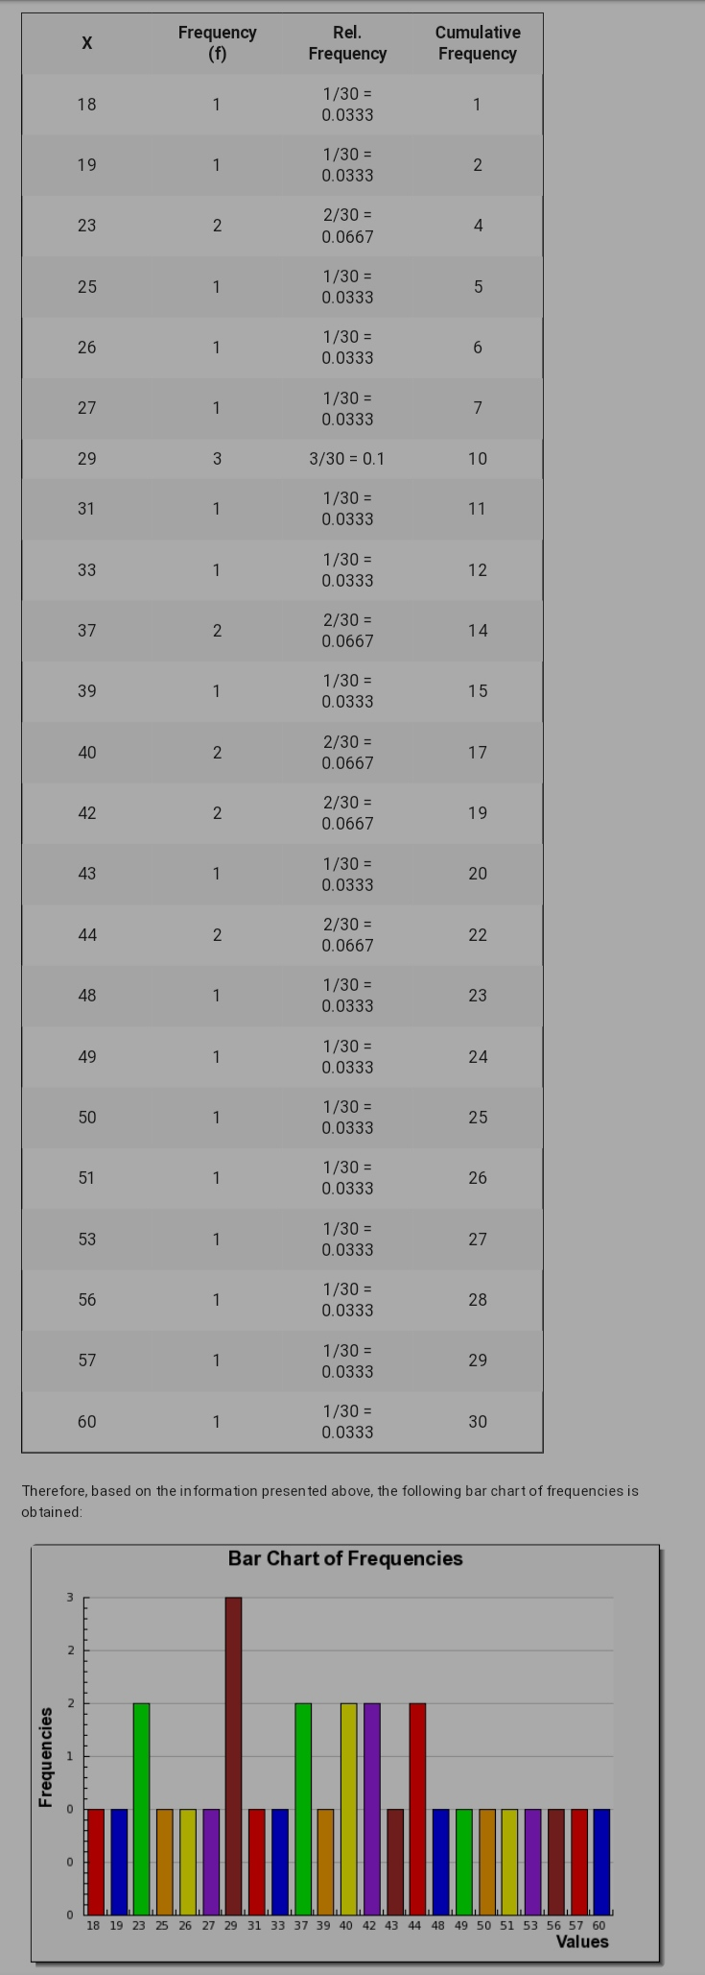

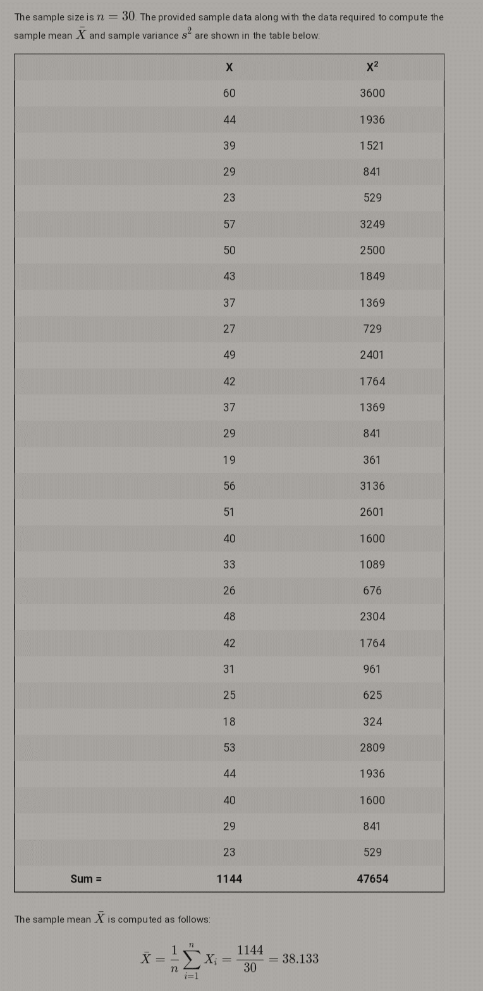

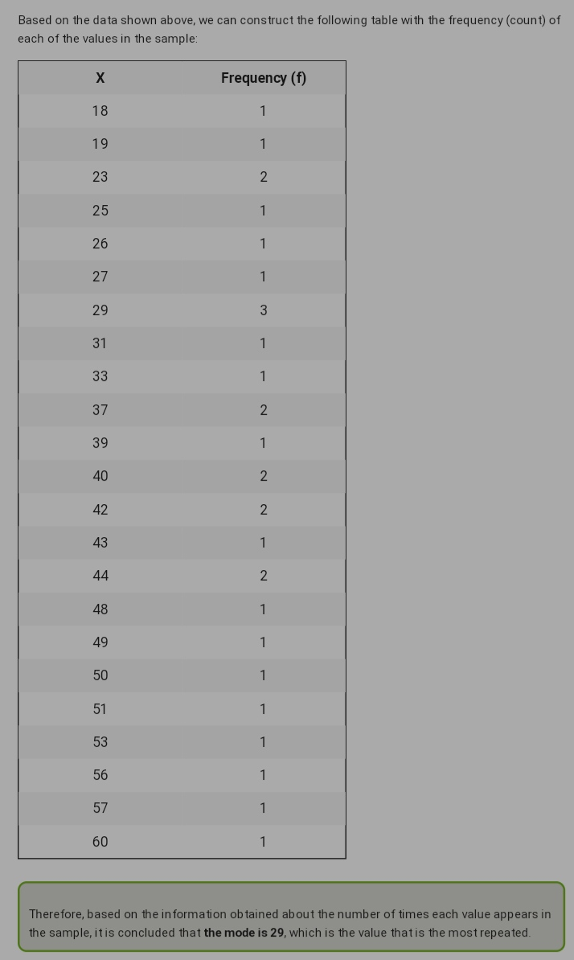

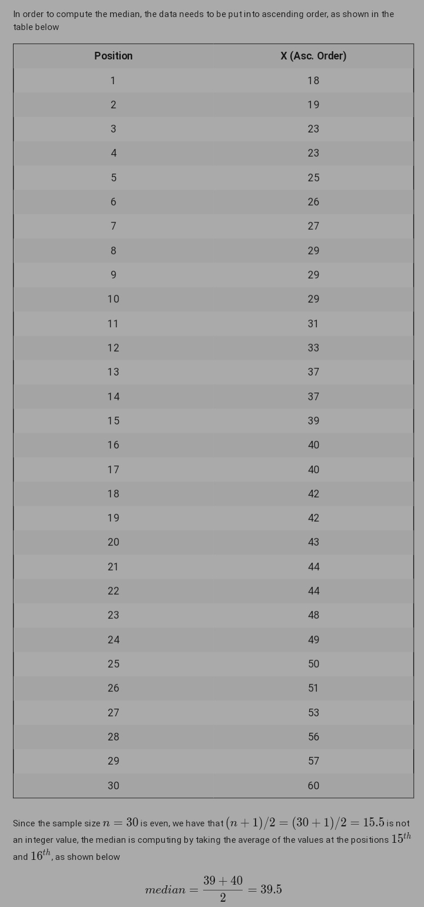

3.

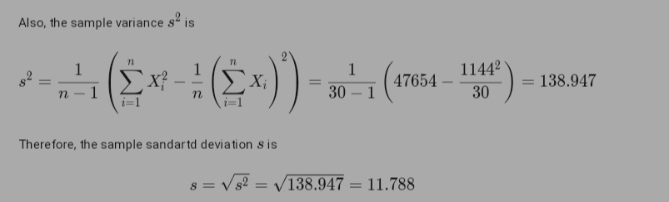

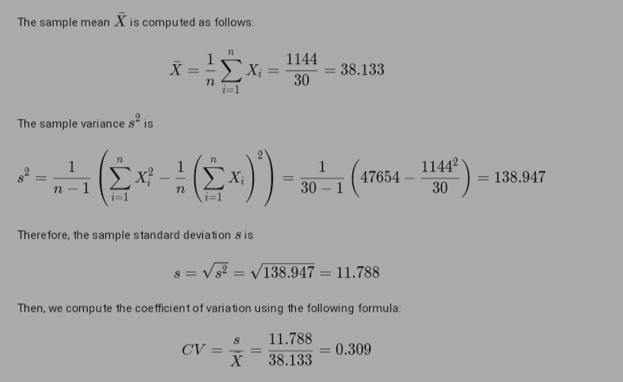

4. By the frequency table the team had 41wins = 2+1+2+1+1+1+1+1+1+1+1=13

For Z score the formula is x-\mu/\sigma

Thus after arranging the data in ascending order and applying the formula of the z score I get

|  |  |
| --- | --- |
| data | Z score |
| 18 | -1.70738 |
| 19 | -1.62256 |
| 23 | -1.28329 |
| 23 | -1.28329 |
| 25 | -1.11366 |
| 26 | -1.02884 |
| 27 | -0.94402 |
| 29 | -0.77439 |
| 29 | -0.77439 |
| 29 | -0.77439 |
| 31 | -0.60475 |
| 33 | -0.43511 |
| 37 | -0.09584 |
| 37 | -0.09584 |
| 39 | 0.073791 |
| 40 | 0.158609 |
| 40 | 0.158609 |
| 42 | 0.328244 |
| 42 | 0.328244 |
| 43 | 0.413062 |
| 44 | 0.49788 |
| 44 | 0.49788 |
| 48 | 0.83715 |
| 49 | 0.921968 |
| 50 | 1.006785 |
| 51 | 1.091603 |
| 53 | 1.261238 |
| 56 | 1.515691 |
| 57 | 1.600509 |
| 60 | 1.854962 |

The lowest Z score is of 18 having -1.71

The highest Z score is of 60 having 1.85

The Z score of 37 is -0.096

